**Genomic surveillance of SARS-CoV-2 in Belgium**

Report of the National Reference Laboratory (UZ Leuven & KU Leuven)

**Situation update – 23th of February 2021**

**(report 2021_13)**

**Executive summary**

Genomic surveillance in Belgium is organised around 3 different arms aiming to monitor the emergence and the further spread of specific viral populations (variants of concern, VOCs) which may impact disease control and/or vaccination strategies.

Through baseline surveillance, an unbiased selection of positive samples from 24 sentinel labs (selected based on geographical dispersion and diversity of clinical patterns) are analysed in designated sequencing platforms. Currently, 6.338 Belgian sequences are available on GISAID. During weeks 6,7 and 8, 670 samples have been sequenced as part of the baseline surveillance, among which 292 were 20I/501Y.V1 (43,6%), 34 were 20H/501Y.V2 (5%) and 8 were 20J/501Y.V3 (1,2%).

The majority of new infections occurring in Belgium are now caused by a VOC. Collectively, they are now driving the dynamics of the epidemic and are causing the number of daily infections to start rising again.

Authors (National Reference Laboratory – UZ Leuven and KU Leuven):

*Piet Maes, Lize Cuypers, Guy Baele, Els Keyaerts, Elke Wollants, Marc Van Ranst, Emmanuel André*

Collaborators of this report (KU Leuven): *Tom Wenseleers*

With the collaboration of the laboratories of UCL, ULB, UMons, UNamur, ULiège, Ugent, UAntwerpen, Jessa ZH, AZ Delta, AZ Klina, IPG, AZ St Lucas Gent, OLV Aalst and UZ Leuven/KU Leuven.

**Table of content**

1. International context
2. Baseline surveillance and proportion of VOCs among new infections in Belgium
3. Temporary (and urgent) utility for a complementary reflex VOC PCR
4. Positivity rate in federal platform laboratories
5. **International context**

Since the end of the year, 4 variants of concern (VOCs) have arisen independently of one another in the United Kingdom (20I/501Y.V1), South Africa (20H/501Y.V2) and Brazil (20J/501Y.V3 and P.2). These variants harbour several mutations and deletions associated with higher infectiousness and immune escape. All variants are spreading internationally, with 3 VOCs having been detected to date in Belgium (1.875 for 20I/501Y.V1, 255 for 20H/501Y.V2 and 19 for 20J/501Y.V3).

1. **Baseline surveillance and proportion of VOCs among new infections in Belgium**

Since support was offered by the federal government end of December 2020, both the temporal coverage (number of sequences performed per week) and geographical coverage (number of collection sites) have improved. Currently, 6.338 Belgian sequences are available on GISAID.

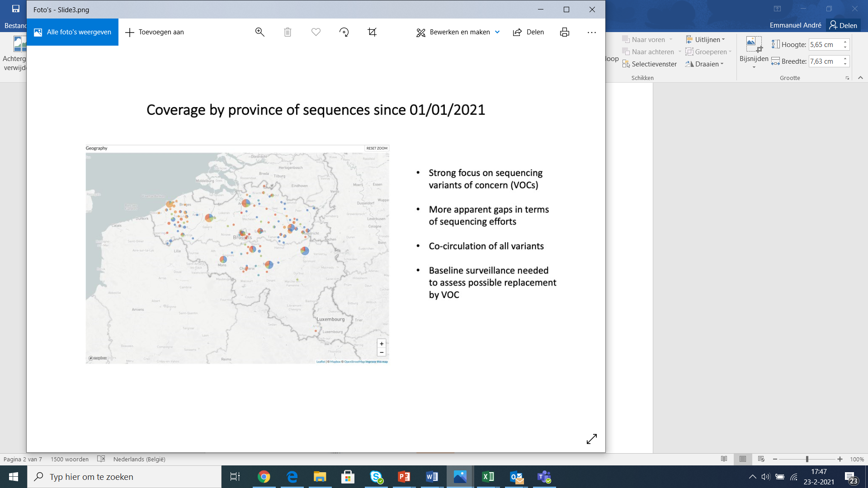

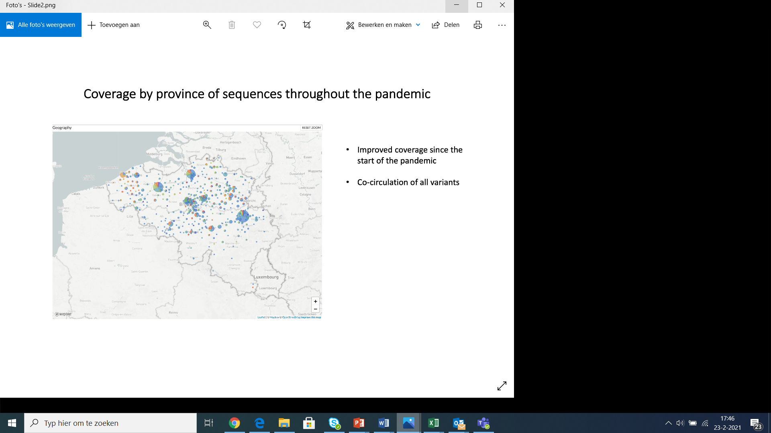

**Figure 1:** Geographical coverage of the genomic surveillance network in Belgium since February 2020 (left) and 1st of January 2021 (right).

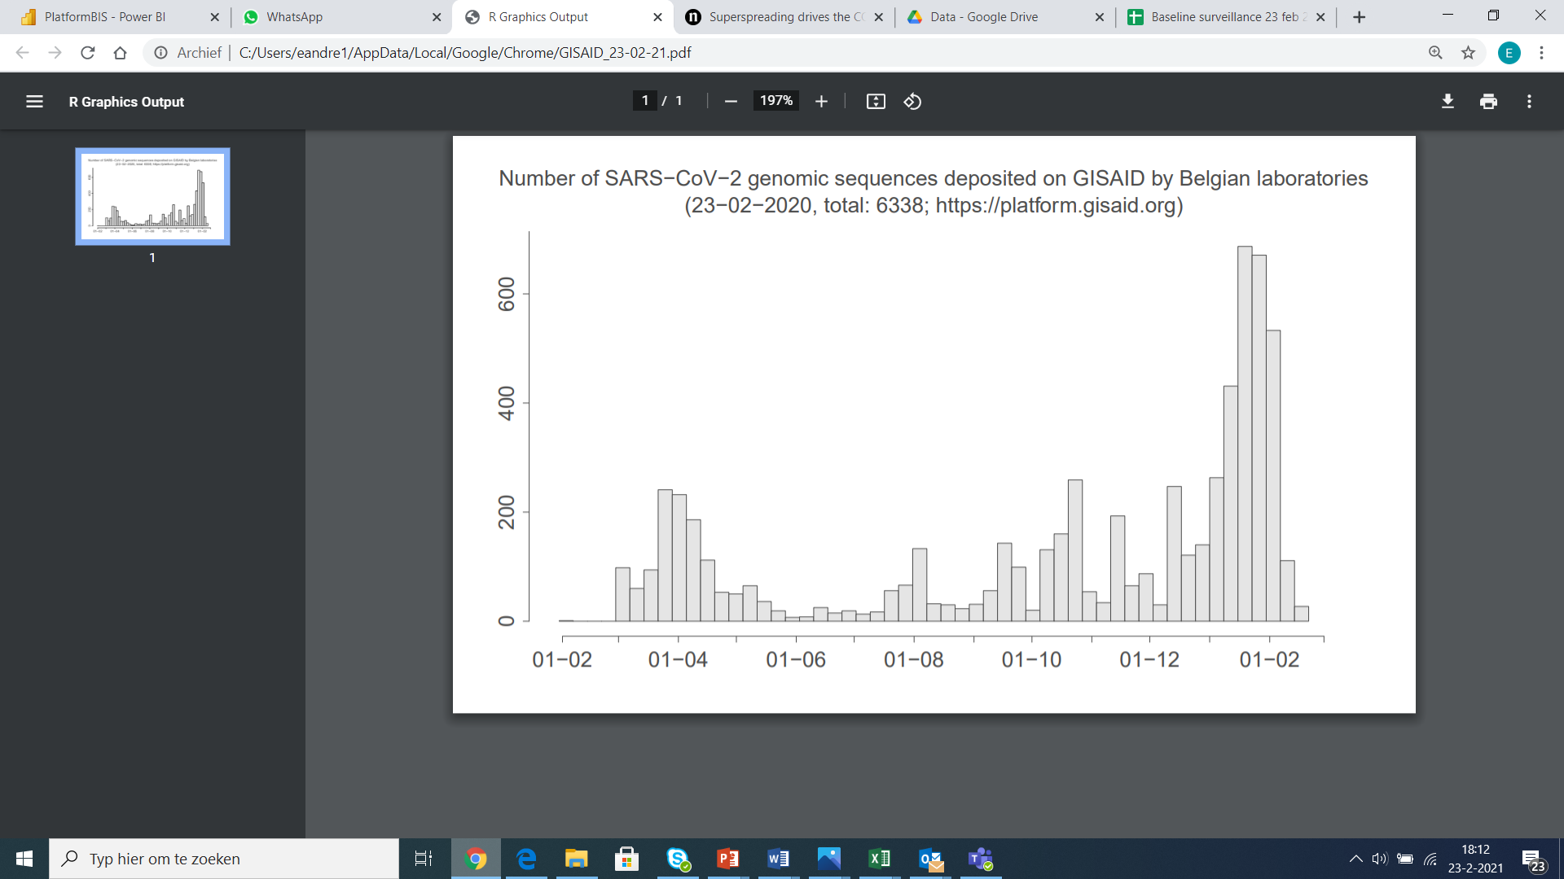

**Figure 2:** Number of sequences deposited on GISAID per week of sampling since the start of the outbreak in Belgium.

Follow-up of 501Y.V1 (B.1.1.7) is performed using an additional indicator, which is the “S dropout” signal detected among positive COVID-19 PCRs reported by the 8 federal platform laboratories. In order to get the best view on the number of recent infections actively contributing to transmission, we consider for the daily follow-up only positive samples for which the N gene has a Cq value under 25. By excluding for this analysis the samples with a Cq value between 25 and 30, we avoid to include possibly older infection and possible false positive S dropout signals that can occur when the signal is close to the limit of detection.

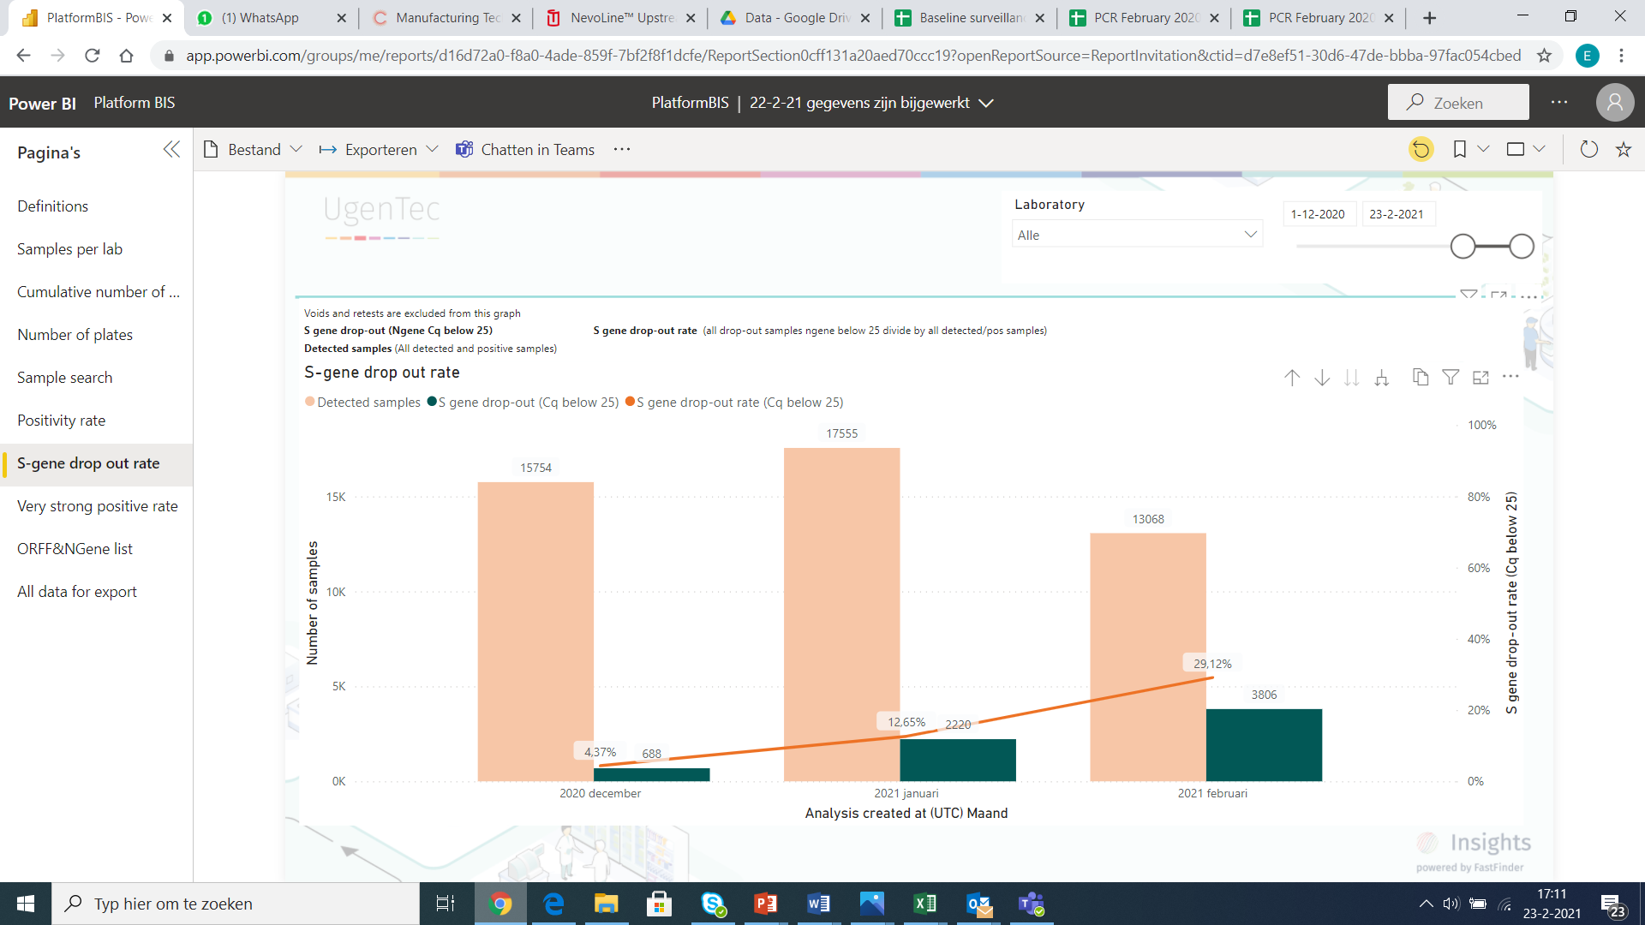

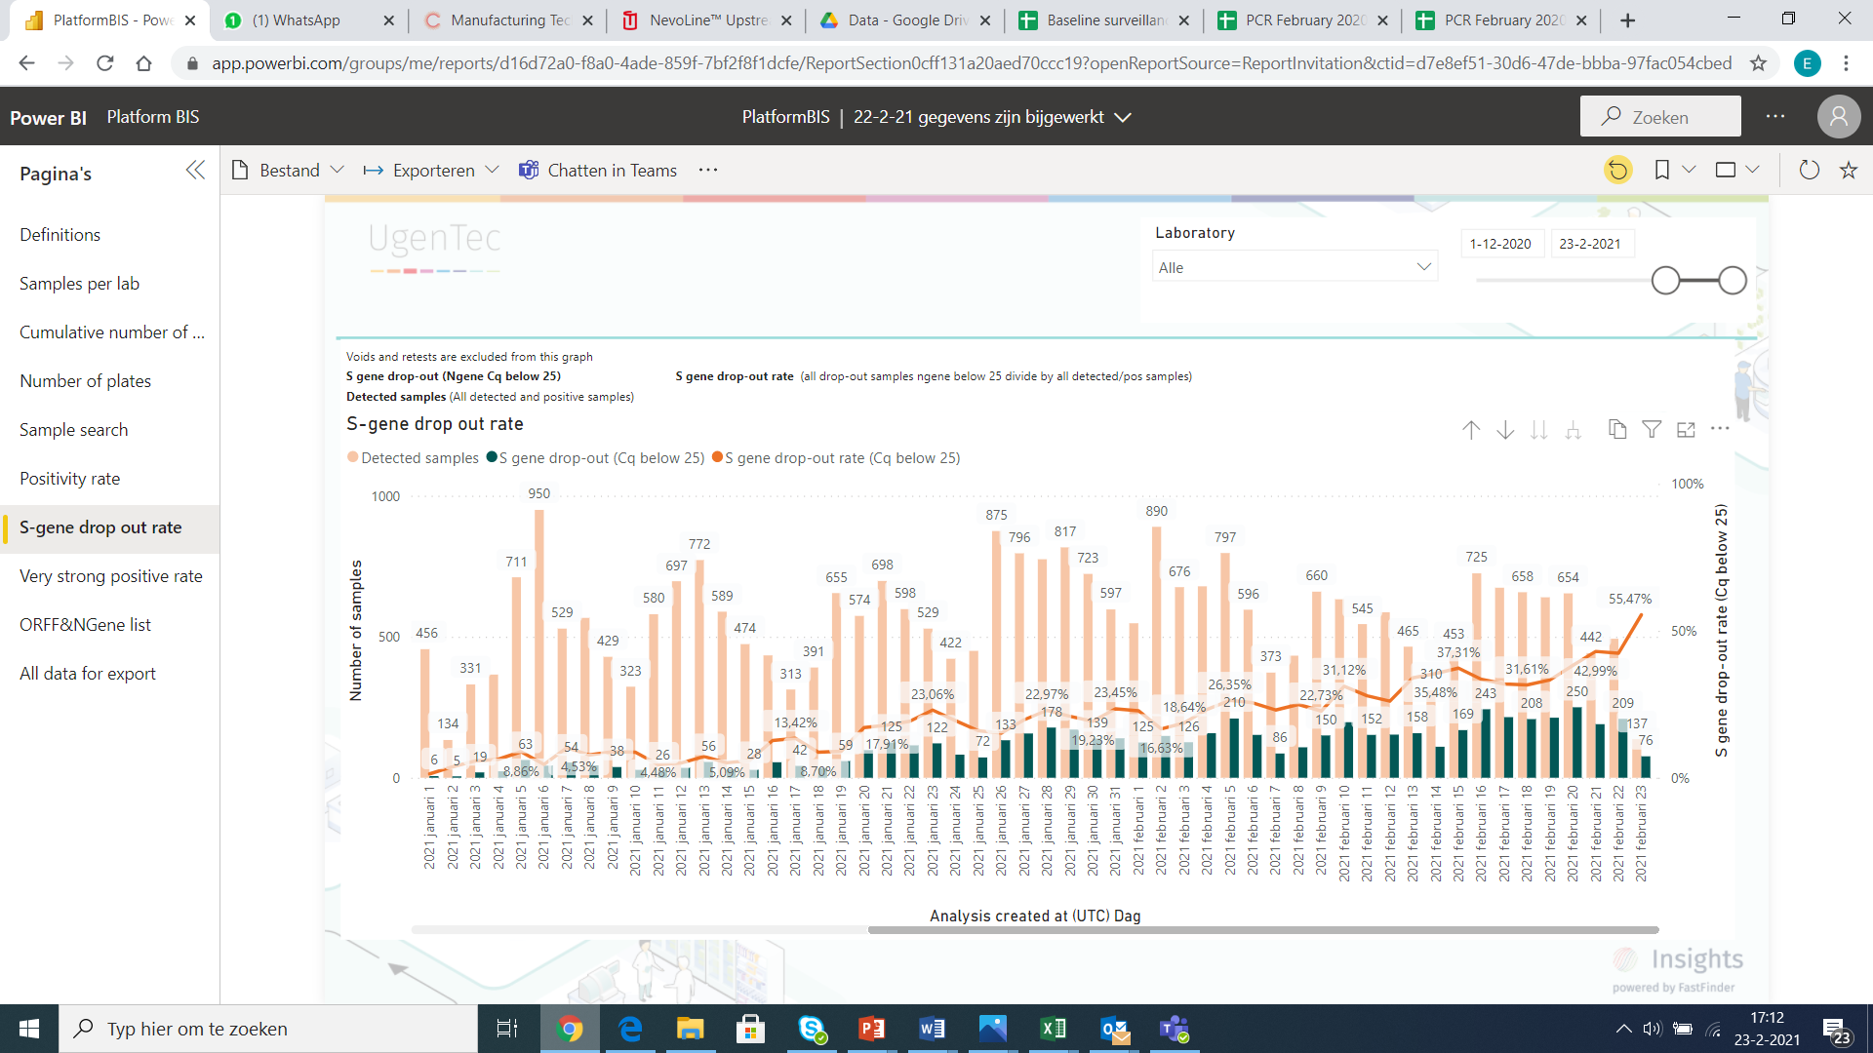

**Figure 3:** Monthly (figure above) and daily (figure below) evolution of the proportion of infectious samples detected among all positive tests diagnosed in the federal platform laboratories (Presence of the S dropout signal and Cq <25). Based on these figures, we estimate that over 40% of the people infected one week ago were infected with a 501Y.V1 variant. This phenomenon is observed in all regions of the country.

A logistic fit (binomial GLMM with XXX) demonstrates that XXX.

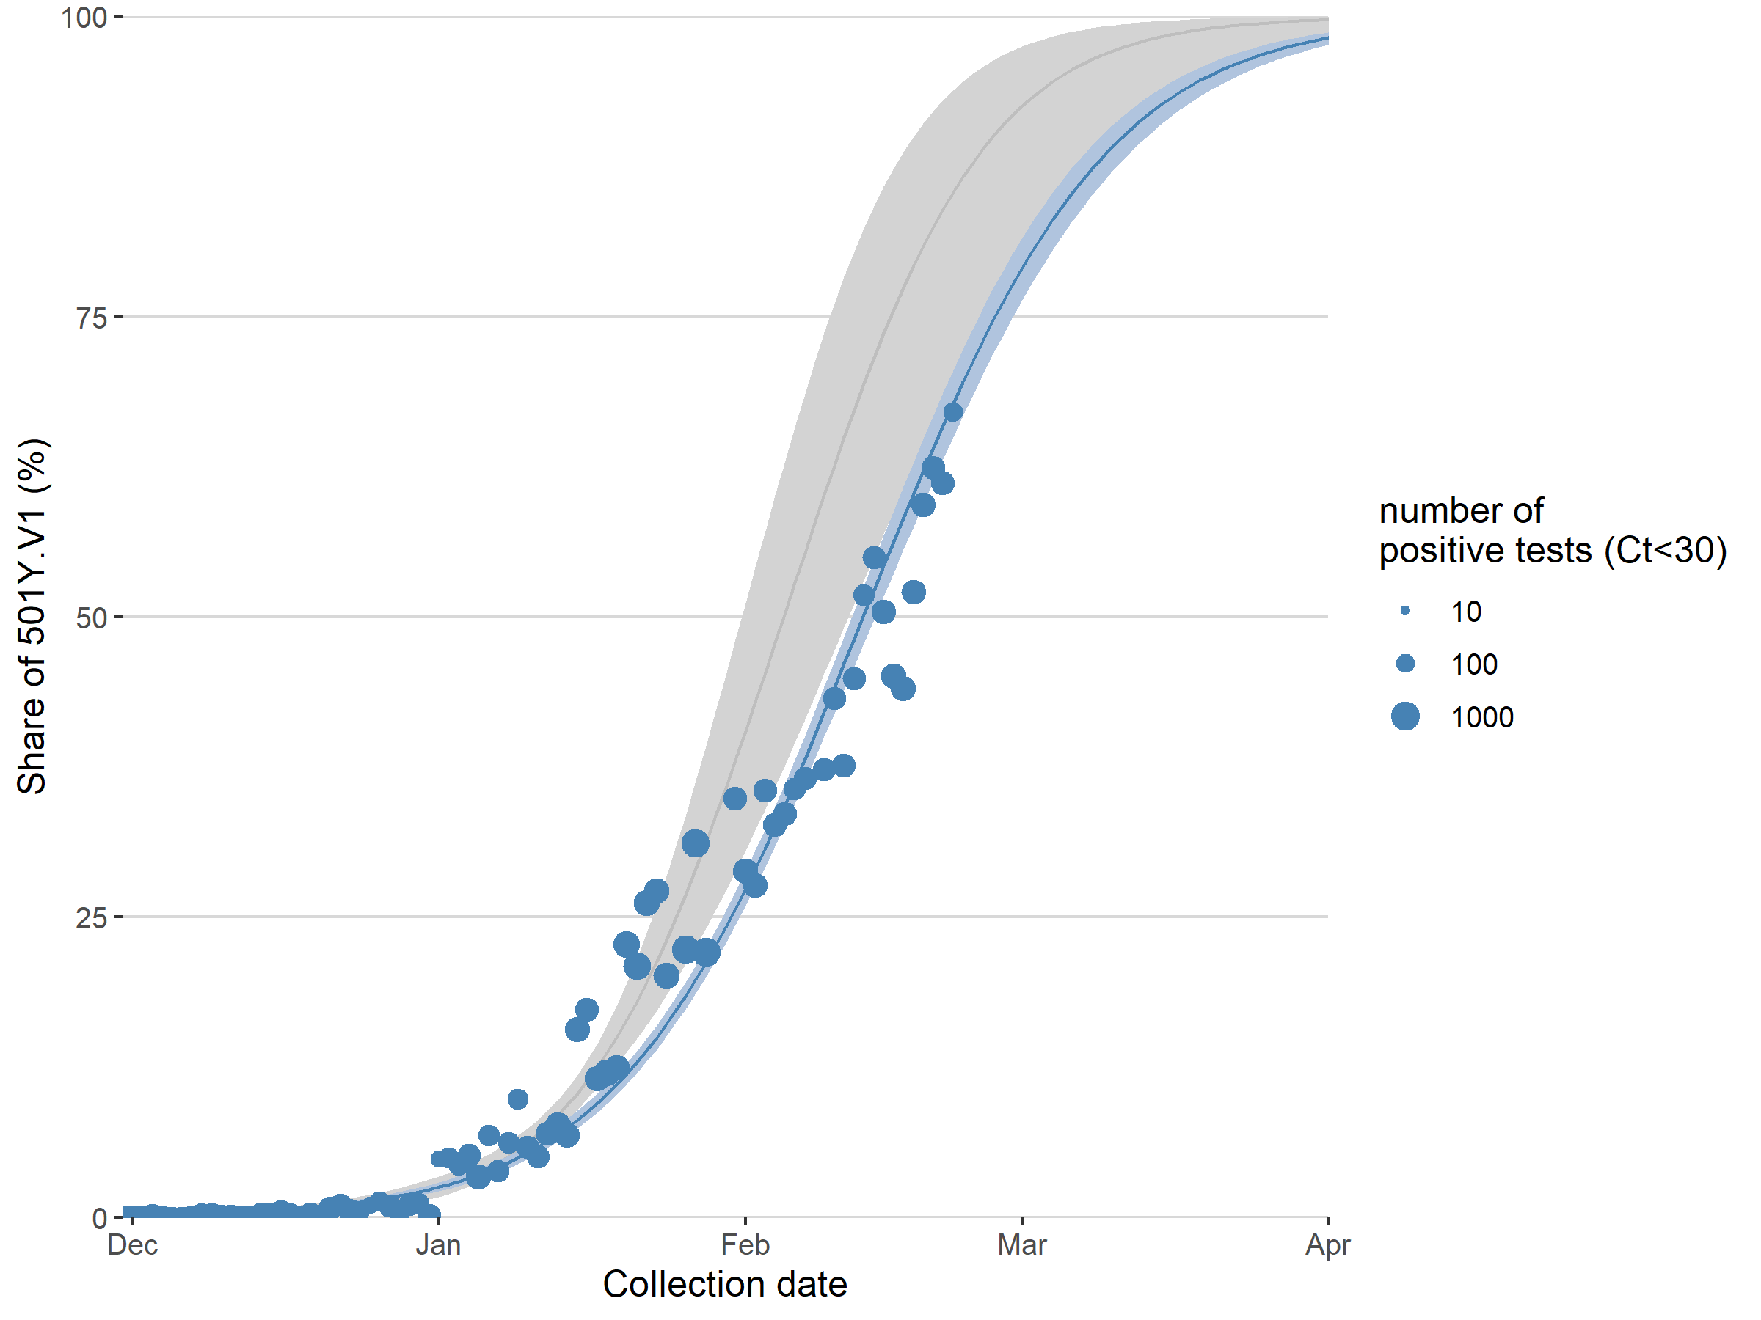

Estimated increase in the relative abundance of the 501Y.V1 variant in Belgium

based on S dropout data (mean and 95% confidence intervals, binomial GLMM with random

intercept for laboratory and an observation-level random effect to take into account

overdispersion, with correction for the expected proportion of true positives). An

extrapolation up to the first of March is shown.

We can further observe that XXX.

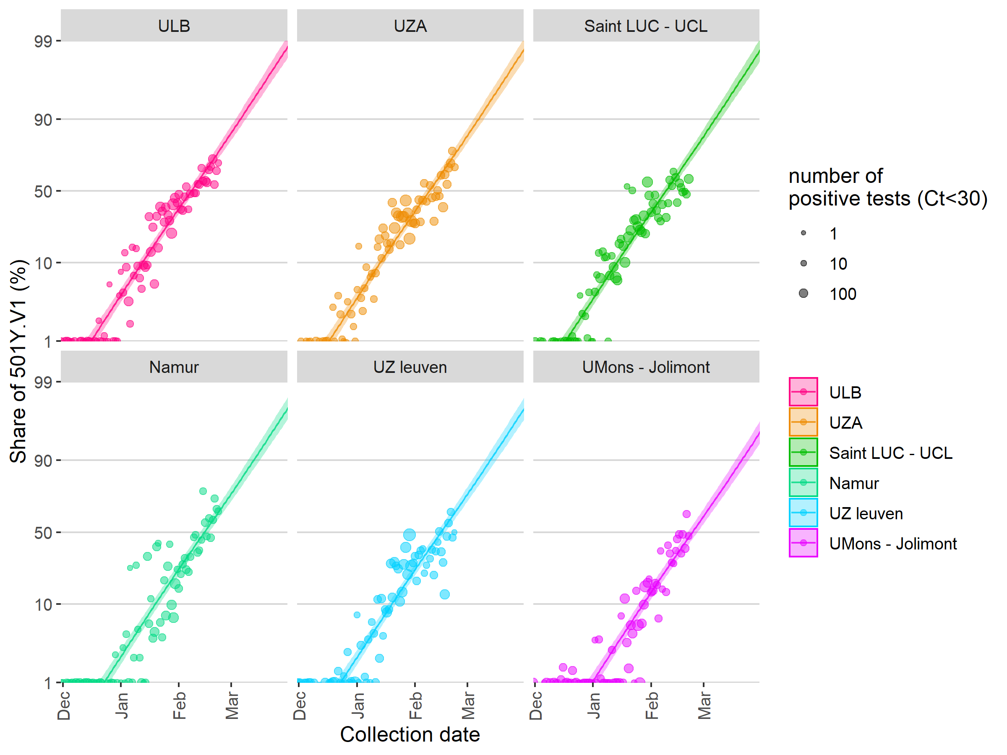

Due to its increasing proportion, the 501Y.V1 variant, which has a higher transmissibility rate compared to other circulating strains and therefore a transmission advantage, has now become a main determinant in driving up the effective reproduction number (Re) of the SARS-CoV2 virus in Belgium.

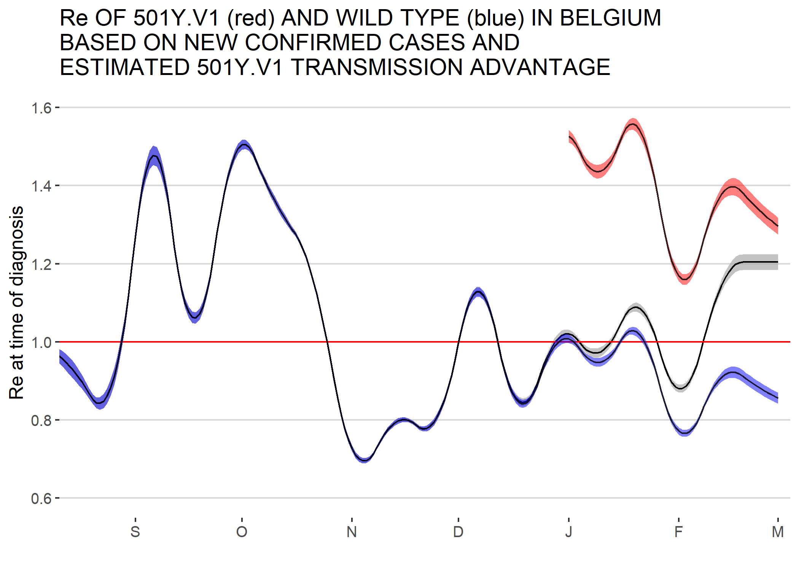

**Figure 5:** The evolution of the reproduction rate (R) in Belgium (black line) is now is now mainly driven by the (R) of the 501Y.V1 (red line), which emerged in Belgium end of December 2020. The (R) of the other circulating strains (blue line) has dropped as a consequence of current disease containment measures.

During weeks 6,7 and 8, 670 samples have been sequenced as part of the baseline surveillance, among which 292 were 20I/501Y.V1 (43,6%), 34 were 20H/501Y.V2 (5%) and 8 were 20J/501Y.V3 (1,2%). Based on these figures, we estimate that over 50% of the people infected one week ago were infected with one of the 3 VOCs currently circulating in Belgium.

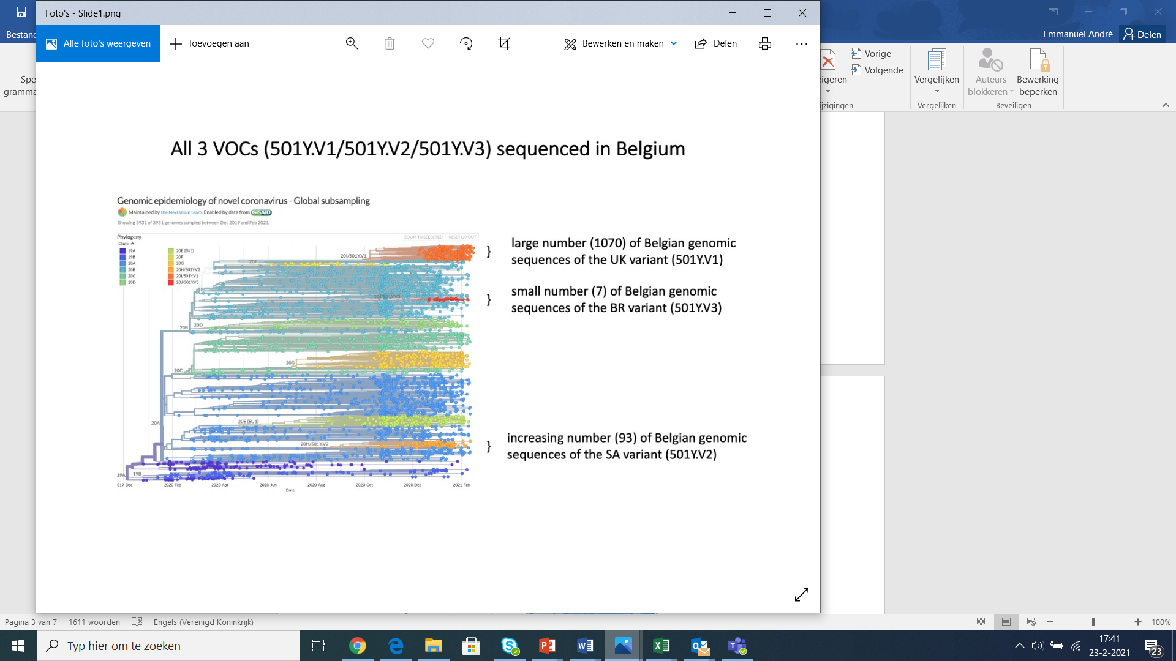

**Figure 4:** Nextstrain build of currently available sequences from Belgium. VOCs are highlighted in dark orange (20I/501Y.V1), light orange (20H/501Y.V2) and red (20J/501Y.V3).

1. **Temporary (and urgent) utility of a reflex VOC PCR**

Since the start of the COVID-19 pandemic, viral mutants have continuously emerged as a consequence of high level SARS-CoV-2 circulation. In a first phase, non-pharmaceutical interventions such as contact-restriction policies, have led to the selection of more transmissible variants. In a second phase, the virus is put under pressure to be able to evolve in populations with a partial herd immunity, and experiencing a stepwise rollout of vaccination.

During the upcoming months, a period characterized by incomplete immune protection, partial immunity status will probably become a major driver of selection for variants better adapted to escape human immunity. To date, a limited number of VOCs have been described, and controlling the spread of mutants harbouring an immune escape mechanisms (in particular S:E484K) at least during the vaccination rollout period.

Performing a reflex PCR on all (or a significant proportion) of positive samples would allow to rapidly detect and subsequently contain community clusters of transmission related to such VOCs. Considering the financial benefits made by clinical laboratories for diagnostic PCR tests, we consider that this reflex PCR should be performed at no cost for the public health budget. The implementation of such PCR should be considered as necessary as long as VOCs harbouring the S:E484K mutation remain a minority of the circulating strains and as long as the health inspectors can handle the workload related to the specific interventions required.

Based on a literature review, we list hereunder a series of combinations of mutations of concern that would allow to detect and characterize the currently described VOCs, namely 20I/501Y.V1 (B.1.17), 20H/501Y.V2 (B1.351), 20J/501Y.P1 (B.1.1.28.1) and 20J/501Y.P2 (B.1.1.28.2). The list of selected candidates is represented in the table below, and comprises mostly mutations located in the receptor binding domain of the Spike gene. The minimal requirement for such PCR would be to detect at least S:E484K and S:N501Y.

|  |  |  |  |  |  |  |  |
| --- | --- | --- | --- | --- | --- | --- | --- |
|  | S:N501Y | S:del69 | S:A570D | S:E484K | S:K417N | S:K417T | Orf1b del |
| 20I/501Y.V1 | YES | YES | YES | Possible | NO | NO | NO |
| 20H/501Y.V2 | YES | NO | NO | YES | YES | NO | YES |
| 20J/501Y.P1 | YES | NO | NO | YES | NO | YES | YES |
| 20J/501Y.P2 | YES | NO | NO | YES | NO | NO | YES |

1. **Positivity rate in federal platform laboratories**

The positivity rate among samples tested is expected to rise of there is insufficient testing capacity compared to the actual current need. We can observe that the positivity rate has increased from January to February, although it still remains under 10%.

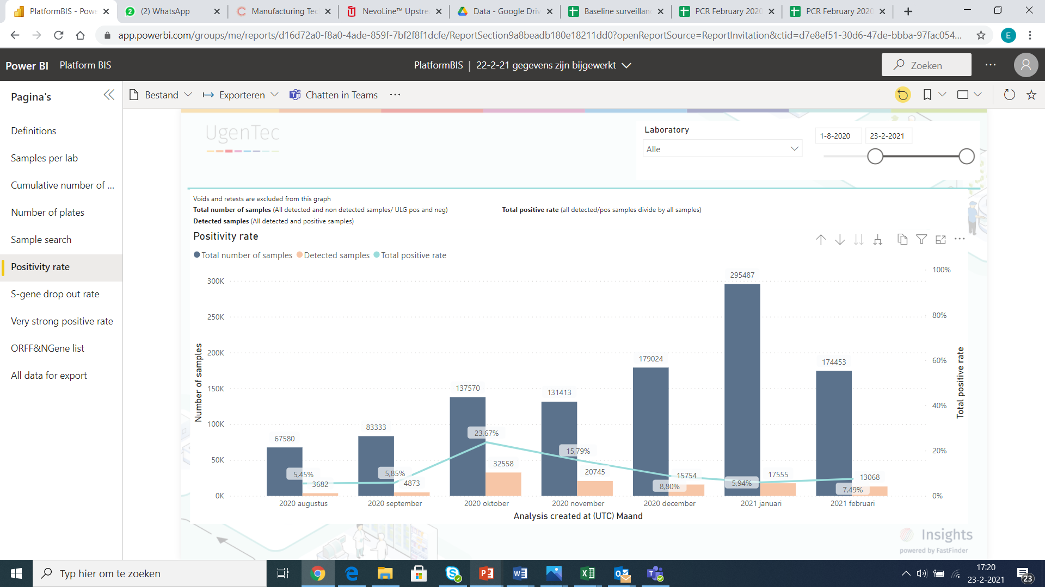

The proportion of positive samples presenting a very high viral load (Cq < 15) can be seen as the number of patients diagnosed during the first days of infection. This proportion tends to increase when the tracing is efficient in identifying transmission events, but can also be observed in the early weeks of a resurgence. This rate has increased from January to February, and is for the month of February at the level observed in September 2020, a few weeks before the second wave. This proportion has reached 30% during the last week, a proportion comparable with the month of October 2020, at the start of the second wave.

